Fiber Optic Cable Closure

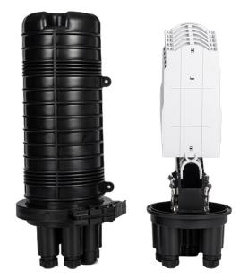
FSC-D006M MAX144

Description
optical splice closures are used to distribute, splice, and store the
outdoor optical cables which enter and exit from the ends of the
closure. There are two connection ways: direct connection and splitting connection. They are applicable to situations such as overhead, man- well of pipeline, embedded situation etc. Comparing with terminal box, the closure requires much stricter requirement of seal. Sealing ring and air valve are required for closure, but that are not necessary for
terminal box.
Features
1. The closure casing is made of quality engineering plastics, and of good performance of anti-erosion against acid and alkali salt, anti-aging, as well as smooth appearance and reliable mechanical structure.
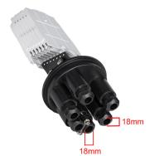
2.The mechanical structure is reliable and has the performance of resisting wild environment and intensive climate changes and serious working
environment. The protection grade reaches IP68.
3.The closures are applicable to ribbon type optical cable and common optical cable.
4.The splice trays inside the closure are turn-able like booklets, and have
adequate curvature radius and space for winding optical fiber to make sure
the curvature radius for optical winding 40mm.Each optical cable and fiber can be operated individually.

5.The closure is of small volume, big capacity and convenient maintenance.
Mechanical seal Type
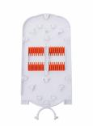
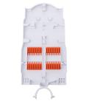
The elastic rubber seal rings inside the closure are of good sealing and sweat-proof performance.
6.The casing can be opened repeatedly without air leakage. No special tools are required. The operation is easy and simple. The air valve is provided for the closure and used to check the sealing performance.

<A> <B
Standard Accessories
Tag paper:1pcs Sand paper :1pcs spanner:2pcs  Sealing rubber strip：1pcs Insulating tape：1pcs  Cleaning tissue：1pcs  Plastic plug+Rubber plug：10 pcs Cable tie:3mm*10mm 12pcs  Fiber protective tube：3pcs  Heat-shrink sleeve:1.0mm*3mm*60mm 12-144pcs Pole accessories:1 pcs（Optional Accessories ）  Aerial accessories:1 pcs（Optional Accessories ）  Pressure testing valve：1pcs （Optional Accessories ） | 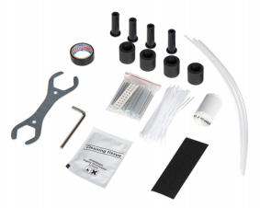

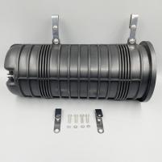
Optional Accessories
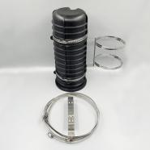
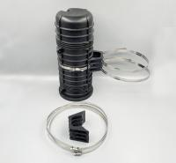
Pole mounting（A） Pole mounting（B） Air mounting（ C）

Dimensions an Capability

Dimensions (H*D) | 470mm*220mm
Max Capacity | 144 Cores
Number of Cable Entrance/Exit | 2:4
Diameter of Cable | 2 big round ports(18mm) and 4 small round ports(18mm)

Technical Specifications
Seal performance: after the box is sealed, inflate to 100kPa inwards (inflation only apply to the models with the air hole), and then soak it in the water of normal temperature, after 15 minutes of steady observation, there is no bubble to
overflow.
Insulation resistance: the insulation resistance between the metalwork piece and the earth is greater than 20kMΩ .
Pressurization: there is no breakdown or flashover under 15kVdc/1min between the metalwork piece and the earth. The curvature radius of the fiber 40mm, without extra loss inside the splice tray.
It can bear the axial tensile strength no less than 1000N.
Lifetime: 25 years.
Other performances are all in accordance with the requirement of standard YD/T814-1998.

Mechanical Seal Splitting and Splicing Closure

Quick Installation Guide

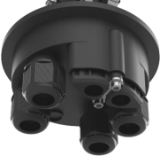
Appearance and Structure
Grommet
Splicing tray
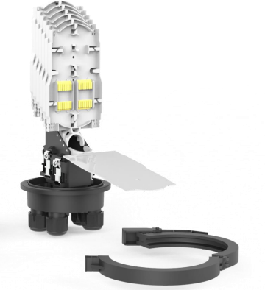
Feeder optical cable hole
Drop optical cable hole

Structure for
fixing optical cables

Gasket

Clamp ring

Installation Tools
Marker | Long measuring tape (3 m) | Hacksaw | Scissors | Claw hammer
Phillips  screwdrivers(M3-M6) | Flat-head screwdrivers (M3-M6) | Fiber splicing tools (splicer knife, and cleaner) | Optical cable/fiber stripping tool | Diagonal pliers
Hex key | Torque wrench | Pliers | Hammer drill | Chisel
Ø10 drill bit | Protective gloves | Buffer tube slitter
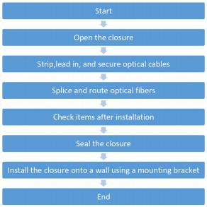
Installation Flow

1. Put away materials that are not used during the installation for future use.
2. Put away components that are removed during t he installation and protect them against contamin ation.
3. Clean components before installation.
! CAUTION

Mechanical Seal Splitting and Splicing Closure

Quick Installation Guide

1. Open the closure.
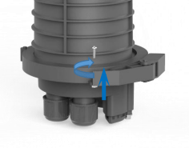
1. To open the closure, do as follows: a)Pull the latch on the clamping ring outward. b)Open the clamping ring. c)Remove the clamping ring, the cap of the closure, and the velcro tape.
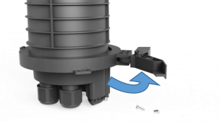

1. Strip, lead in, and secure the optical cable.


a. Strip the straight through optical cable.
WARNING
Handle the strength member of the optical cable carefully as it is sharp and may cause bodily injuries.
!
1 Mark the position where the optical cable is to be stripped.
2 Determine the length to be stripped from each section of the optical cable and then strip the optical cable.
3 Strip the branching part by 1800 mm: a)Strip the loose tubes using a stripping knife. b)Cut off the loose tubes at both ends. C)Put the bare optical fiber through a protection tube.
4 a)Wrap insulation tape over the stripped part of the optical cable.
b)Ensure that the insulation tape is 8 mm to 10 mm longer than the stripping endface.

50mm
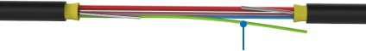

Strength member

1800mm
Straight through part

Branching part

50mm

Strength member

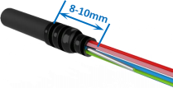

Stripping endface of the drop optical
cable

b. Strip the drop optical cable.
1 Determine the length to be stripped from each section of the drop optical cable.
2 a)Strip the drop optical cable by the required length, and clean the loose tube. b)Put the bare drop optical cable through a protection tube. c)Wrap the stripping endface tightly using insulation tape.

1400mm


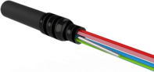
Stripping endface of the drop optical
cable

C.Lead in and secure the optical cable.
1 a)Remove the screws on the pressure plate of the feeder optical cable aperture. b)Remove the pressure plate, dual-hole pressure plate, dual-hole gasket, and dual-hole gasket block. C)Cut the dual-hole gasket along the red lines, as shown in figure c below. d)Lead the stripped optical cable through the feeder cable aperture on the closure.

Mechanical Seal Splitting and Splicing Closure

Quick Installation Guide
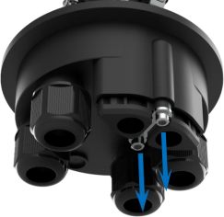

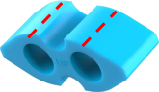
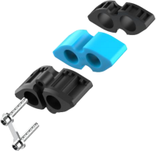
Dual-hole
Gasket block
Dual-hole
gasket

Dual-hole
pressure plate

o— Pressure plate

2. Strip, lead in, and secure the optical cable (continued).

1. Lead in and secure the optical cable(continued).
1.a)Unscrew the hose clamp b)Unscrew the fixing plate for the strength member.
3.Lead the optical cable through the hose clamp and place the strength member under the fixing plate. a)Secure the fixing plate for the strength member. b)Secure the hose clamp.
4.Coil the straight through optical cable.

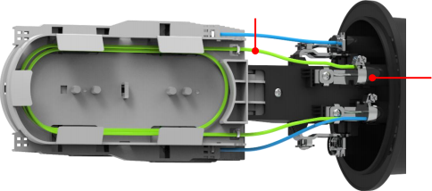
Cable tie
Hose clamp
Fixing plate for the strength member

5.a)Install the pressure plate of the feeder optical cable aperture, dual-hole pressure block, dual-hole gasket, and dual-
hole gasket block. b)Apply silicone grease on the opening of the dual-hole gasket. c)Push the pressure plate of the feeder optical cable aperture, dual-hole pressure plate, dual-hole gasket, and dual-hole gasket block one by one along the feeder optical cable until they are fitted into the feeder optical cable apertures, and then tighten the screws on the pressure plate.
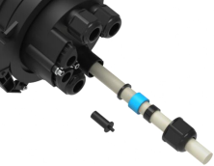
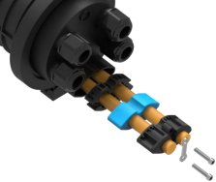

Mechanical Seal Splitting and Splicing Closure

Quick Installation Guide

4.Splice, terminate, and route optical fibers
2 a) Punch holes in the block using the flat-head screwdriver, and wear the metal gasket, four-hole gasket, metal gasket, and nut one by one on the drop optical cable in sequence as shown in the following figure. b) Lead the drop optical cable through the aperture and hose clamp, and secure the hose clamp. c)Push the metal gaskets, four-hole gasket, and nut into the aperture, and tighten the nut.
3 Splice inbound and outbound optical fibers.
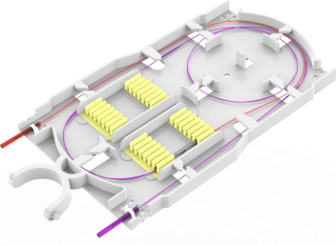
4 a)Coil the optical fibers. b)Secure the splicing protection tube. c)Install the splicing tray cover.

Feeder optical cable Drop optical cable
Straight through Optical cable
Branching part
Outbound optical
Cable of splicing tray

5 a)Install splicing tray 1 in the sequence of the preceding steps 2to 4. b)Tie the splicing trays and straight-through tray using a Velcro tape.

4. Check the following items after the installation

NO. | Check ltem
1 | Each screw is tightened.
2 | Optical cables and fibers are secured.
3 | The gasket on the shell is flat (press down the gasket if it bulges) and the closure is properly sealed.
4 | The bending radius of optical fibers must meet the requirement(adjust optical fibers if necessary).

5. Seal the closure.
a) Install the closure cap. b)Install the clamping ring on the shell and seal the closure.

6. Install the closure onto a wall using a mounting bracket.
a) Install expansion bolts into the positions on the wall as shown in the following figure. b)Position the rear part of the
mounting bracket onto the expansion bolts on the wall, and secure the rear part of the mounting bracket onto the
wall.
