Fiber Optic Distribution Box
PB-0408K

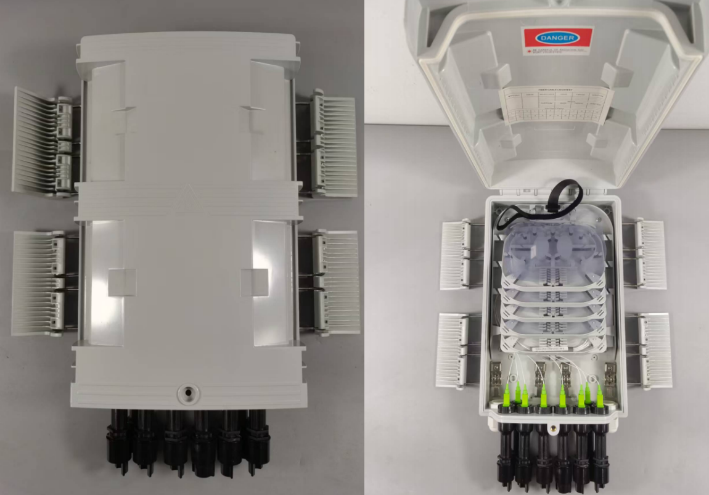

1. Description:
The equipment is used as a termination point for the feeder cable to connect with
drop cable in FTTx communication network system. The fiber splicing, splitting, and distribution can be done in this box, and meanwhile it provides solid protection and management for the FTTx network building

2. Features:
1. Total enclosed structure.
2. Material:PC+ABS, wet-proof, water-proof, dust-proof, anti-aging, protection level up to IP65.
3. Clamping for feeder cable and drop cable, fiber splicing, fixation, storage, distribution...etc all in one.
4. Cable, pigtails, and patch cords are running through their own paths without disturbing each other, micro type PLC splitter installation, easy maintenance.
5. Distribution panel can be flipped up, feeder cable can be placed by expression port,easy for maintenance and installation.
6. Box can be installed by the way of wall-mounted or poled-mounted, suitable for both indoor and outdoor use.

3. Specification:
1. Environmental requirement
Working temperature: -40℃~+85℃
Relative humidity: ≤85% (+30℃)
Atmospheric pressure: 70KPa~106Kpa
2. Main technical datasheet
Insertion loss: ≤0.15dB
UPC return loss: ≥50dB
APC return loss: ≥60dB
3. Thunder-proof technical datasheet
The insulation resistance between the grounding device and the metal parts of the box is no less than 2×104 MΩ/500V (DC); IR≥2×104 MΩ/500V.
The voltage resistance between the grounding device, and the box and its metal parts is no less than 3000V (DC)/min, no puncture, no flashover; U≥3000V

4. Configuration table:

Table 1 Model and configuration

Model | Size (Pic 1)  A*B*C (mm) | Max  Capacity | Installation Size  (Pic 2)  D*E*F(mm) | Into the largestc  able diameter  (mm) | Maximum sizeo  f branch hole  (mm) | Waterproof SC/AP C adapter
PB-0408K | 400*210*87MM | 8 | 175.5*121MM | ᴓ8~15 | ᴓ15 | 8
