10 Ports Non-open Pre-connectorized Fiber Access

FastConnect Terminal Box

Product Overview

Fiber access terminal box (FAT) also named as optical termination box (OTB), is a compact fiber management box used for FTTH application. Fiber termination box (FTB) is widely used in FTTx cabling for both fiber cabling and cable management.
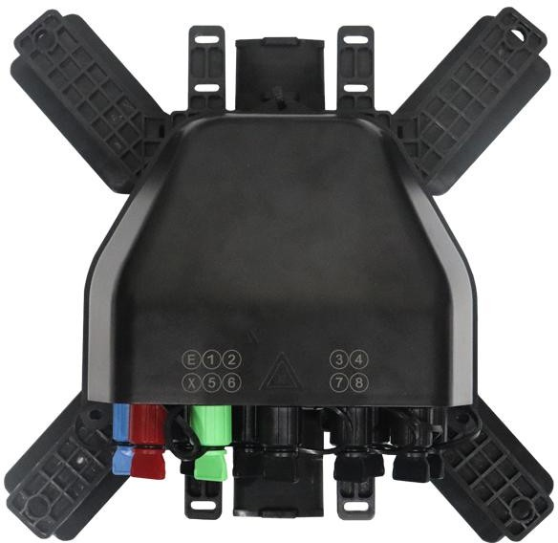

Application

- FTTH;
- FTTA;
- Trunk Cable Connecting.

Feature
- High compatibility support harden adapter of OptiTap, Slim and FastConnect;
- Strong enough: working under 1000N pulling force long term;
- Installation on Wall/Pole/Aerial mounted, underground;;
- Available with PLC fiber divide;
- Decreased angle surface and height make sure no connector interfering when operating;
- Cost effective: save 40% operating time and less manpower.

Technical Parameter

Model | Total Value (dB) | 1x2 FBT High Power (dB) | 1x2 FBT + 1x8 PLC (dB)
90/10 | ≤21.54 | ≤ 0.73 | ≤ (11.04+10.5)
85/15 | ≤ 20.78 | ≤ 1.13 | ≤ (10.28+10.5)
80/20 | ≤ 18.25 | ≤ 1.25 | ≤ (7.75+10.5)
70/30 | ≤ 16.51 | ≤ 2.22 | ≤ (6.01+10.5)
60/40 | ≤ 15.32 | ≤ 2.73 | ≤ (4.82+10.5)
1:8 | ≤ 10.50 | ≤ N/A | ≤ 10.5

Specification Details

Dimension (L x W x H) | 198 x 160 x 70mm
Waterproof Level | IP68
Port Type Solution | 10pcs of Harden FastConnect Adapters
Color | Black
Material | PC + ABS
Max Capacity | 10 Ports
UV resistance | ISO 4892-3
Fire protection rating | UL94-V0
Number of PLC (Solution) | 1x2 FBT Uneven PLC + 1x8 PLC
Warranty Life Time (Non-artificial damage) | 5 Years

Mechanical Parameter

Atmospheric Pressure | 70KPa~106Kpa
Lid opening angle for operating | No, 100% sealed off (Ultrasonic crimping)
Tensile Resistance | ＞1000N
Crush Resistance | ＞2000N/10cm2 Pressure, time 1min
Insulation resistance | ＞2×104MΩ
Compressive Strength | 15KV(DC)/1min no breakdown and no arcing.
Relative Humidity | ≤93％ (+40℃)

Storage Temperature | -40℃ ～ +85℃
Operating Temperature | -40℃ ～ +60℃
Installation Temperature | -40℃ ～ +60℃

Application Scheme
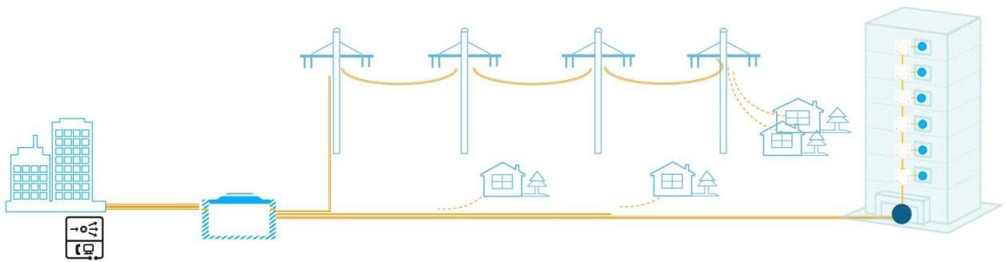
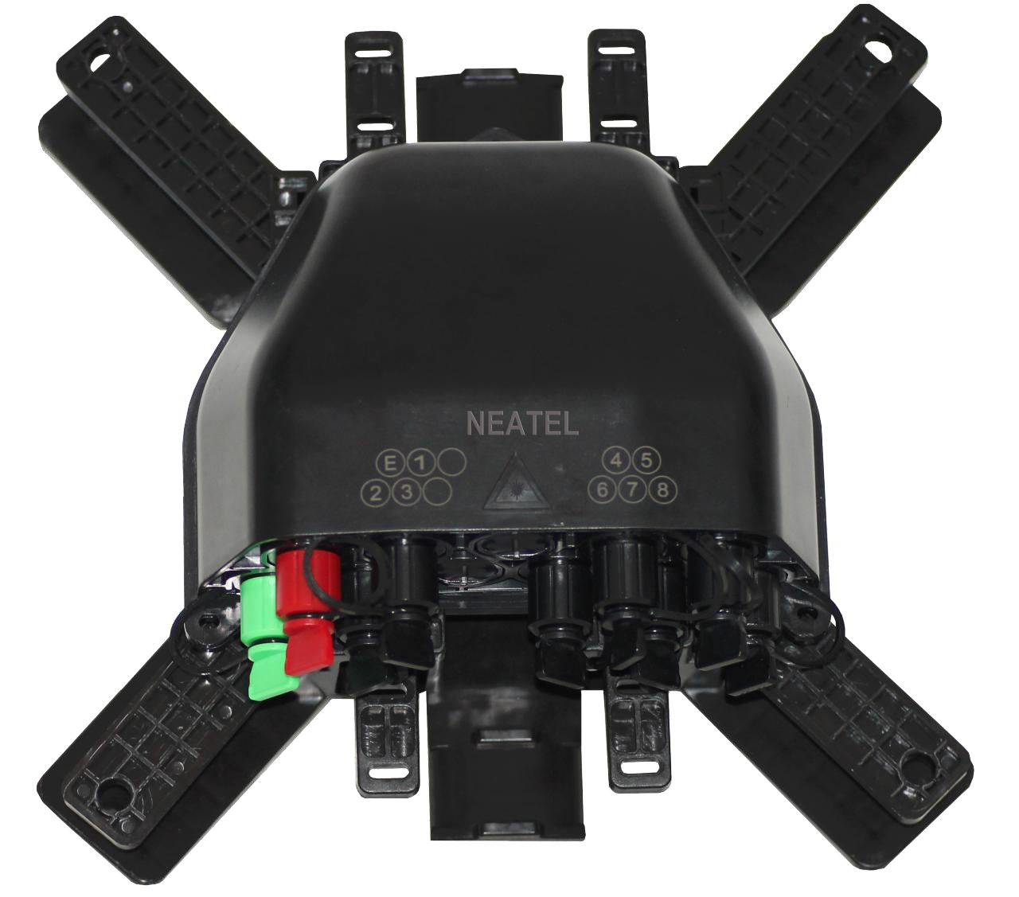
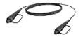
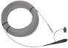
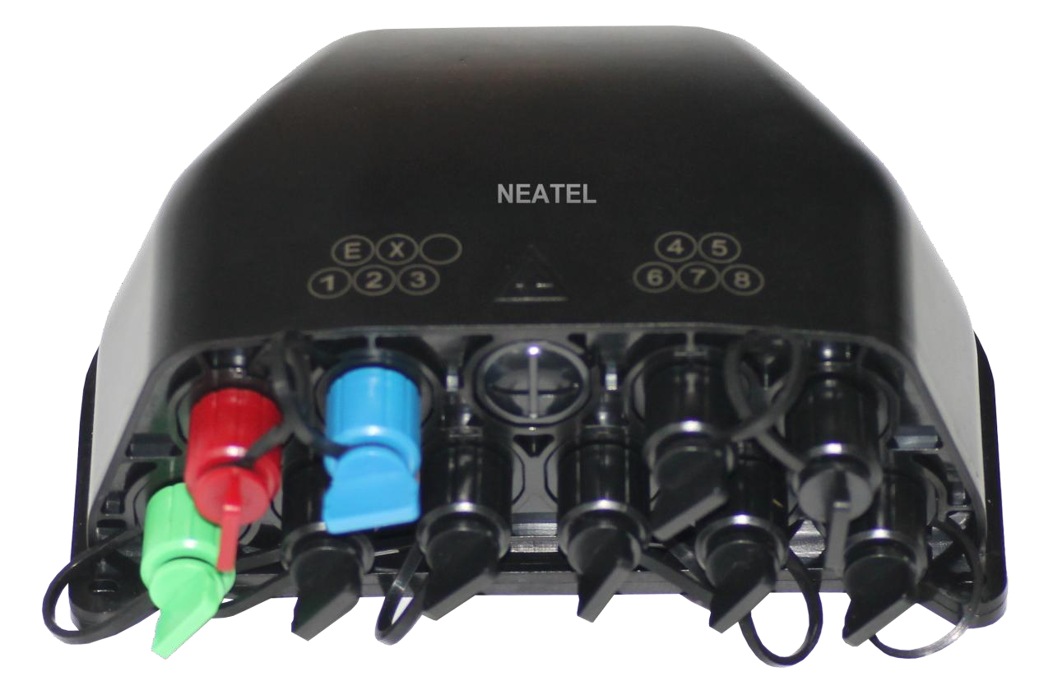
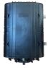
➋ 3 PCS Uneven Box
➊ Fiber Cable
➌ End Box
➋ Drop Flat Cable
1x9
1 FO
1x9
1 FO
1x9
1 FO
1x8
50m
50m
50m
1 FO
➊ Hub Box
1 FO
1 FO
CO
MDU single fiber solution
Indoor Duct
Outdoor multi-fiber solutions
Ground
Outdoor single fiber solution
Ground / Duct

PLC Splitter Diagram

Drawing of PLC Splitter: 1 x 9 Solution

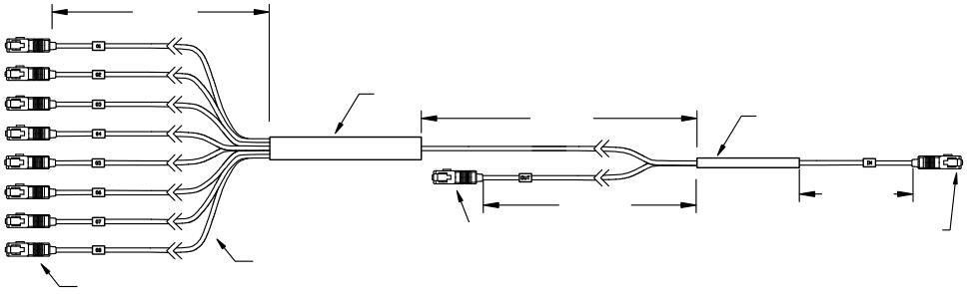
Port 1
35mm
1:8 PLC Splitter
15cm
1: 2 FBT, 60/40, 70/30, 80/20
85/15, 90/10 Optional INPUT
S/N: XXXXXXXXX
50cm
50cm

SC/APC Connector (Green Color)
900um Loose Tube 8 Colors
SC/APC Connector (Green Color)
Port 2
Port 3
Side B
Port 4
Side A
Port 5
Port 6
Port 7
Port 8

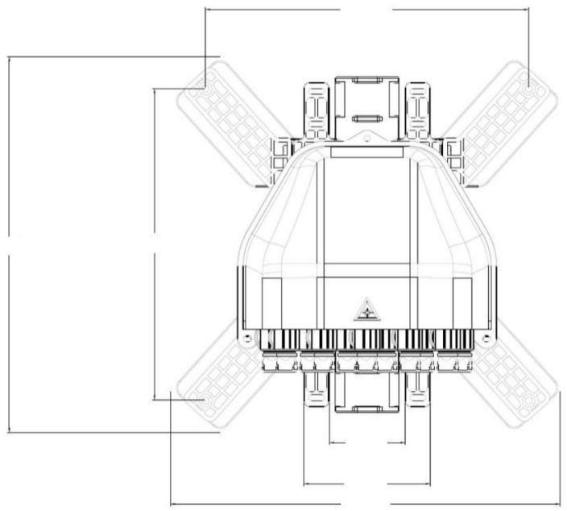
249
290
240
59
97
300
Including Accessories

Item Description | Picture | Qty
L40mm Screw | 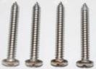 | 4
Ø15mm*6mm  Hex Socket Head Cap Screw | 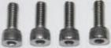 | 4
Ø20mm*6mm  Hex Socket Head Cap Screw | 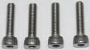 | 4
Ø8mm*3.5mm  Hex Nuts | 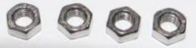 | 4
Ø8mm*40mm  Drilling drywall anchors | 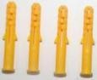 | 4
Ø9mm Metal Lock Washer | 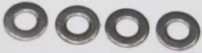 | 4
Ø260mm Stainless Steel Hose Ring | 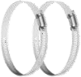 | 2
Ø3mm*12cm  L Handle Allen Wrench Kit | 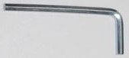 | 1
Wing Nuts 304 Stainless | 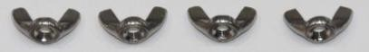 | 4
Cable Storage Kits | 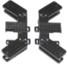 | 2
Aerial-mounted Kit | 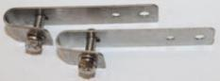 | 2

Product Inner Box Packing

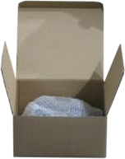 | Size (cm) | 25cm*25cm*13cm
 | QTY (pcs/box) | 1
 | Net Weight (kg/pcs) | 0.61

Accessories Inner Box Packing

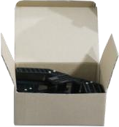 | Size (cm) | 25*25**15cm
 | Set | 8pcs/set
 | G.W (kg/box) | 0.6

Master Carton for Product

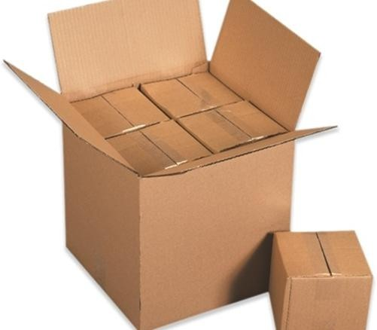 | Size (cm) | 63cm*50cm*48cm
 | QTY (pcs/box) | 12
 | Net Weight (kg/Carton) | 7.2

Master Carton for Accessories

 | Size (cm) | 63cm*50cm*48cm
 | QTY (Sets/box) | 12
 | Net Weight (kg/Carton) | 7.5

