Fast Connector

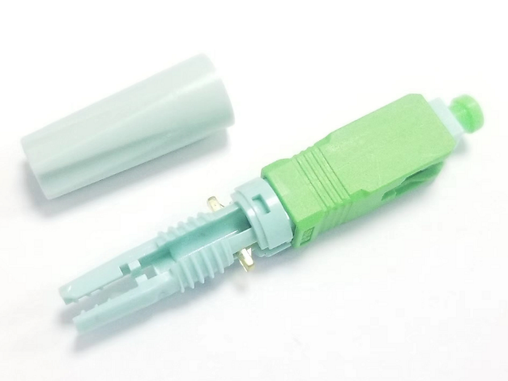
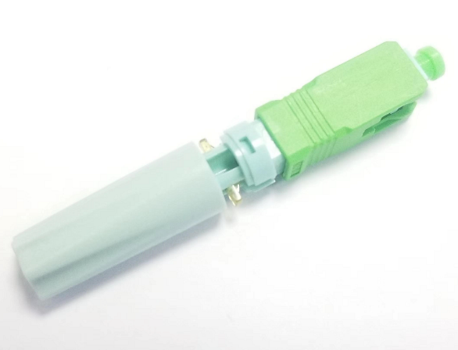

product description:
1. Push-tube type fastening structure, optical fiber fastening, stable and reliable docking.
2. One-piece structure, simple structure, stable and reliable, excellent comprehensive cost.
3.Simple operation, fast construction speed, high installation success rate, long life cycle, simple and convenient post-maintenance.
Product Structure：
Measured the Structure
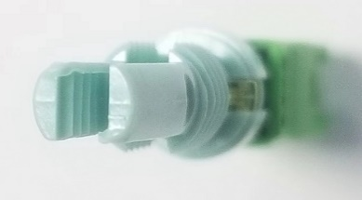
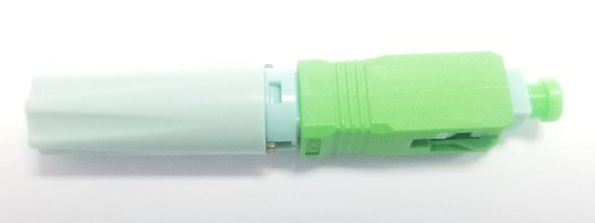

Product length：
50mm ≤L≤60mm(≈54m)
Ptical Characteristics：
Category | Specification
Aoolicable for | Drop cable. Indoor cable
Fiber mod | Single mode or Multi mode
Fiber type | G.652D, G.657A2,
Fiber cable | 3.0*2.0mm rubber-insulated optical cable
Fiber diameter | 0.125mm
Force holds 2 x 3mm cable type at the beginning the fast connector | ≥ 50 N, loss ≤ 0.3 dB
Fiber lock | Lock holds fiber reliability, bears hang force ≥ 1 N, attenuation changes ≤ 0.2 dB
Working wavelength | 1310 nm, 1490 nm, 1550 nm

Operation time | S | About 50(no fiber cut)
Insertion Loss | dB | ≤0.5
Insertion Loss Typical value | dB | 0.3
Return Loss | dB | UPC≥50, APC≥55
Fastening strength of naked fiber | N | ≥3
Tensile strength | N | ≥45
Reusable | Time | ≥10 time
Operating Temperature |  | -40~+85
On-line tensile strength（20N） | dB | ΔIL≤0.3
Mechanical durability (500 times) | dB | ΔIL≤0.3
Drop-off test (drop-off height4m, once per direction, totally 3 times) | dB | ΔIL≤0.3
Environmental performance requirements:
Category | Specification
Category | Condition | IL Variation | RL Variation | Appearance
High TEMP | 85℃, 168H | ≤0.3 | ≤5 | No mechanical da mage, like deform ation, cracking and untight
Low TEMP | -40℃, 168H | ≤0.3 | ≤5
Temperature Cycle | Cycle: 8 hours  Total: 12 cycles / 168 hours  Temperature Maintenance: 1 hour | ≤0.3 | ≤5
Temperature/ Humidity | 85℃, 95%RH, 168H | ≤0.3 | ≤5
Immersion | 25℃, 168H | ≤0.3 | ≤5
Salt Mis | 5% Nacl, 6.5＜PH＜ 7.5,35℃,168H | ≤0.3 | ≤5
Mechanical Performance Requirement
Category | Specification
Category | Condition | IL Variation | RL Variation | Appearance
Impact | Height: 4m; 1 drop each axis; 3 cycles | ≤0.3 | ≤5 | No mechanical da mage, like deforma tion, cracking and untight
Vibration | Frequency: 10 ～ 50HZ;  Sweep: 45 times / min;  amplitude: 0.75mm;  Duration:30min each axial | ≤0.3 | ≤5
Torsional | Pull：15N; The distance between Loading location and fast connector: L = 22-28cm; Rate：10times / min. Times: | ≤0.3 | ≤5

Tensile | Pull：50N; The distance between Loading lo cation and fast connector: L = 3M; Duration:1min | ≤0.3 | ≤5
Product Packaging Information：
Blister Box Packing

Adapter (supports strip and cut fiber)：
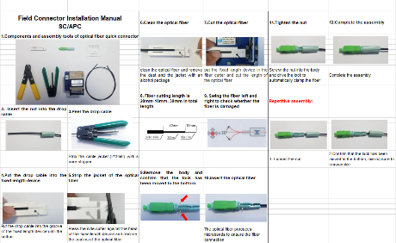
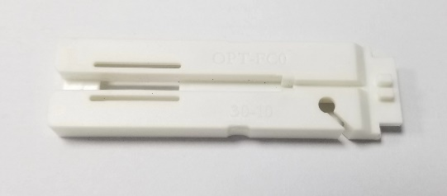

1 adapter / 50 fast con nectors 1 Operation Manual/ 100 fast con ne

